**How to run CompressionApp:**

1. Debug Mode:
   1. In the project’s properties (“Debug” tab) set 3 parameters:

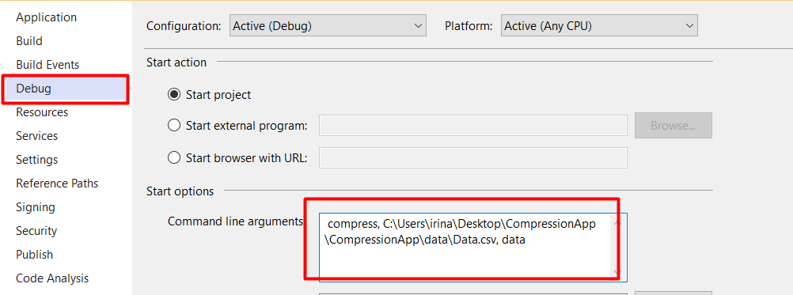

* 1. Run Debug

1. Run via CMD:



**The same process for decompress function**

The generated files could be found in the same folder “data”.